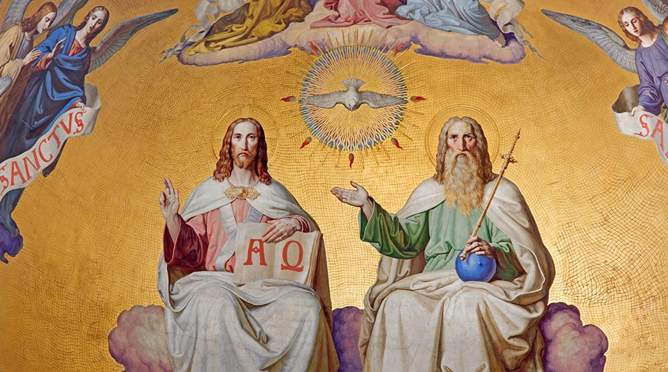
SUNDAY of the MOST HOLY TRINITY

First Reading: Ex. 34:4-6, 8-9
Moses rose early in the morning and went up on Mount Sinai, as the Lord had commanded him, and took in his hand the two tablets of stone. The lord descended in the cloud and stood with him there, and proclaimed the Name, 'The Lord.'
The Lord passed before Moses, and proclaimed, 'The Lord, the Lord, a God merciful and gracious, slow to anger, and abounding in steadfast love and faithfulness.'
And Moses quickly bowed his head toward the earth, and worshipped. He said, 'If now I have found favour in your sight, O Lord, I pray, let the Lord go with us. although this is a stiff-necked people, pardon our iniquity and our sin, and take us for your inheritance.
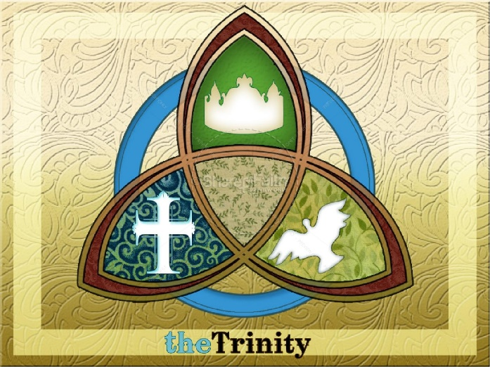

Responsorial Psalm: Daniel 3: 52-56
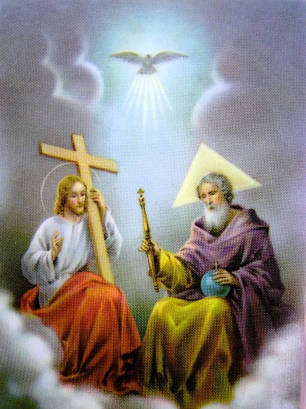
Response: Glory and praise for ever!
You are blest, Lord God of our fathers. Resp.
Blest your glorious holy name. Resp.
You are blest in the temple of your glory. Resp.
You are blest on the throne of your kingdom. Resp.
You are blest who gaze into the depths. Resp.
You are blest in the firmament of the heaven. Resp.

Second Reading: 2 Cor. 13:11-3
Brothers and sisters, put things in order, listen to my appeal, agree with one another, live in peace; and the God of love and peace will be with you. Greet one another with a holy kiss. All the saints greet you.
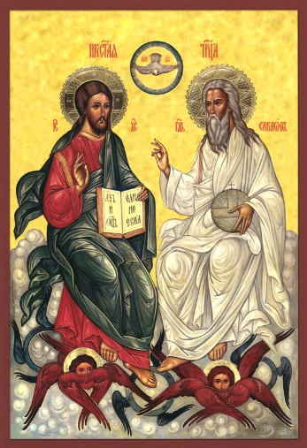
The grace of the Lord Jesus Christ, the love of God, and the communion of the Holy Spirit be with all of you.

Gospel Acclamation:
Alleluia, Alleluia!
Glory be to the Father, the Son, and the Holy Spirit:
To God who is, who was, and who is to come.
Alleluia!

Gospel: Jn. 3:16-8
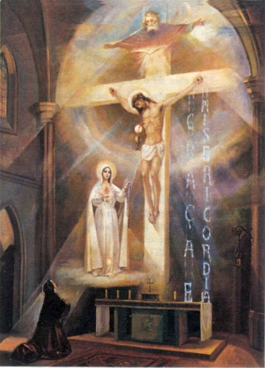
Jesus said to Nicodemus: 'God so loved the world that he gave his only Son, so that everyone who believes in him may not perish but may have eternal life.
Indeed, God did not send the Son into the world to condemn the world, but in order that the world might be saved through him. Those who believe in him are not condemned; but those who do not believe are condemned already, because they have not believed in the name of the only-begotten Son of God.'

Reflections:
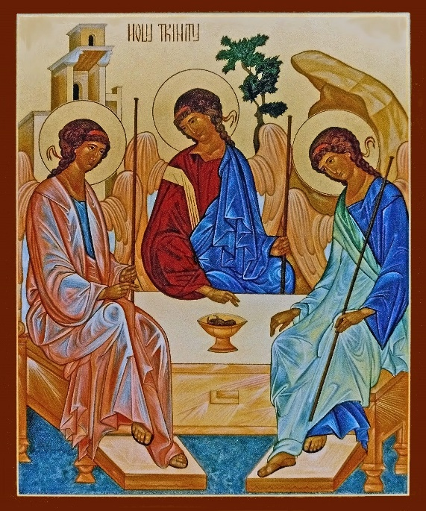
In bygone times practically everybody agreed about the existence of God. At those days, religious divisions came from conflicting beliefs about God, rather than any conflict between theism and atheism. This is not the case nowadays. Not only do many openly profess their lack of faith, but the quality of life we pursue tends to promote a kind of atheism in all of us. Especially in our large cities, surrounded by a world of largely human inventiveness, people are at a distance from the things of nature. As a result even the rural-based of our population are bound to feel in some degree God’s apparent remoteness from our situation, God’s silence, remaining hidden to the end of our earthly days.
Today we celebrate the Most Holy Trinity, the revelation of the mystery of God’s inner life. This mystery will remain for all of us as long as we live in this world, even though the veil which covers it is lifted ever so little. Our Bible assures us that not only is our God a personal God, but God exists as three Persons, Father, Son and Holy Spirit, while remaining one God. Although we cannot even begin to give a logical explanation for this, our faith enables us in some small measure to experience the presence of God. How this can happen is stated by St Augustine in a most beautiful passage from his “Confessions” (p. 211). “What do I love when I love my God?” he asks. Then he continues; “Not material beauty or beauty of a temporal order; not the brilliance of earthly light, so welcome to our eyes; not the sweet melody of harmony and song; not the fragrance of flowers, perfumes and spices; not manna or honey; not limbs such as the body delights to embrace. It is not these that I love when I love my God. And yet, when I love him, it is true that I love a light of a certain kind, a voice, a perfume, a food, an embrace; but they are of the kind that I love in my inner self.” “So tell me something of my God,” he asks. And loud and clear they answered, “God is he who made us.”
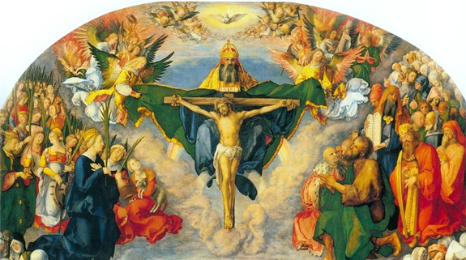
The Holy Trinity is beyond the reach of time and the grasp of human reasoning. It is a mystery of our faith. We can only fumble in the dark in search of glimmers of light. “Two is company, three is a crowd” is a popular expression. The gospel would have it otherwise. There, the figure three symbolises completeness and perfect symmetry, and re-appears at all the key moments of the Christ story. His life itself constantly reflected the Trinity. Three figures make up the nativity scene in Bethlehem — the Holy Family of Jesus, Mary and Joseph. Their first visitors were the three wise men. Later, in the desert preparing to begin his public life, Jesus was tempted three times by the devil. A good story should have a beginning, a middle and an end. Christ was a storyteller par excellence and three figures prominently in his parables. The Prodigal Son is about a father and his two sons; the Good Samaritan tells of the behaviour of three passers-by, the priest, the Levite and the Samaritan; the sower sowed his seed in three different types of terrain, yielding three different levels of harvest. The end of his life, as the beginning, has again the three motif. During his Passion, Peter denied him twice. On the road to Calvary, he fell three times. The crucifixion scene has three figures, Christ between two thieves. Before his resurrection, he spent three days in the tomb.
God is love. There are Three Persons in the Trinity, the Father the Son and the Holy Spirit. Together they represent the fullness of love. The Father loves the Son, the Son loves the Father. The Holy Spirit is their love for each other. We are made in the image of a triune God. God the Father, who created us, his Son who saved us, and the Holy Spirit who continues to guide us. Our lives should reflect the Trinity. We should be always creative like the Father, compassionate like his Son, and dispose our talents in the service of others like the Holy Spirit.
